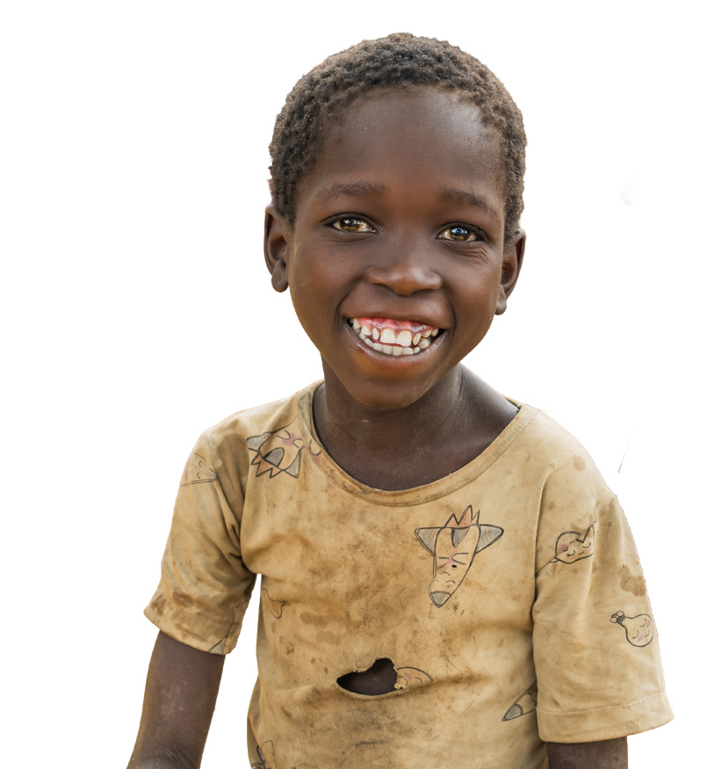
Parish bulletins are an effective way to share with your parishioners the work of missionaries being supported through the Catholic Mission Church Appeal, and a nice way to thank them for their generosity and support.

Parish Bulletins
You may also choose to share our Catholic Mission social media posts with your parishioners. We encourage you to like and follow Catholic Mission on Facebook, Instagram, and YouTube using the following:


 facebook.com/catholicmission  instagram.com/catholicmission youtube.com/catholicmissiontv
SCAN HERE TO DOWNLOAD
THE RESOURCES
Please publish the parish bulletins below in the weeks prior, of, and after your appeal. You can find the plain text and individual images for all bulletins at catholicmission.org.au/parishes for you to easily place in your parish newsletters and share on your website or social media.

Three weeks prior to appeal:



This year marks 100 years of World Mission Day, a time in which the global Church celebrates God’s mission through prayer and generosity.
Today, that mission continues in places like Malawi, where communities are rebuilding after devastating floods and families are striving to create a future for their children.

In the coming weeks, we will share how the Church is walking alongside these communities, and how you can be part of this living mission of love.
To learn more about Catholic Mission and our work, please go to catholicmission.org.au/united.

2026 Catholic Mission Church Appeal Parish Bulletins
See next page
for more Bulletins 1

Two weeks prior to appeal:

Freecall: 1800 257 296 catholicmission.org.au/united
In two weeks, we will share the story of Yamikani*, a young boy in rural Malawi whose daily journey to school is filled with hardship.

You will also meet Fr Matthew Semba who is leading a project to build a new school close to home, so children like Yamikani can learn safely and begin to imagine a future beyond survival.
Through your prayers and support, you are part of this mission, helping to ensure that no child is left behind.
To learn more about Catholic Mission and our work, please go to catholicmission.org.au/united.
*Name changed for privacy

One week prior to the appeal:

Freecall: 1800 257 296 catholicmission.org.au/united
For Yamikani*, getting to school means walking long distances in pain, often without enough food or strength to make the journey. For many families in vulnerable and remote areas like rural Malawi, education has become an impossible choice.

But there is hope. Led by Fr Matthew Semba, a new primary school is being built, offering children a safe place to learn, grow, and look ahead with renewed possibility.

This World Mission Month, you are invited to share in this mission, standing with families as they rebuild their lives and create a brighter future for their children.
*Name changed for privacy

On appeal weekend:

Freecall: 1800 257 296 catholicmission.org.au/united
This week, you are invited to partner with Catholic Mission and the Church in Malawi as we support families rebuilding after devastating floods and help children access education close to home.
Through projects like St Peter’s Nyamikuta Primary School, the Church is creating a place where children can learn,
be nourished, and grow with dignity, regardless of their background or beliefs.
As we celebrate 100 years of World Mission Day, we are reminded by Pope Leo XIV that we are ‘One in Christ, United in Mission’.

Join with us in celebration and action by supporting this work with a compassionate gift. Use the provided appeal envelope, scan the QR code, or visit
catholicmission.org.au/united to make a difference today.


2026 Catholic Mission Church Appeal Parish Bulletins
See next page
for more Bulletins 2

One week after appeal:

Freecall: 1800 257 296 catholicmission.org.au/united

Thank you for your generous support of the Church in Malawi and the communities it serves.
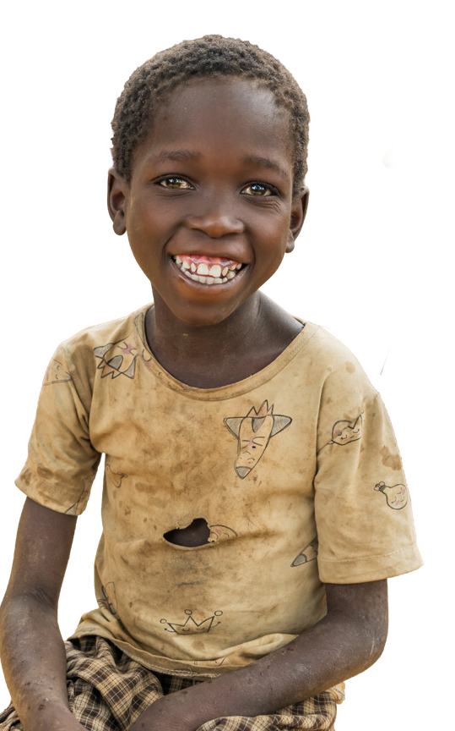
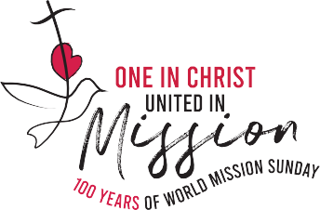
Because of your kindness, children like Yamikani* will have greater access to education, nourishment, and the opportunity to build a hopeful future.
And if you chose to become a Mission Partner with a monthly gift - thank you so much for your ongoing commitment.
To learn more about the work of Catholic Mission in Malawi and around the world, please visit catholicmission.org.au/our-work.
Thank you again for your compassion, and please keep this impactful work in your prayers.
*Name changed for privacy

Second week after appeal:

Freecall: 1800 257 296 catholicmission.org.au/united
On behalf of the Church in Malawi, thank you once again for your generosity.
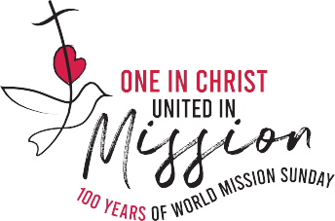
Your support is helping create spaces where children like Yamikani* can learn, families can rebuild, and communities can move forward together.
If you have not yet had the opportunity to donate, please visit catholicmission.org.au/united to lend your support today.
To learn more about the impact you can make through Catholic Mission, visit
catholicmission.org.au/our-work to see other examples of life-giving programs around the world.
*Name changed for privacy

2026 Catholic Mission Church Appeal Parish Bulletins 3

